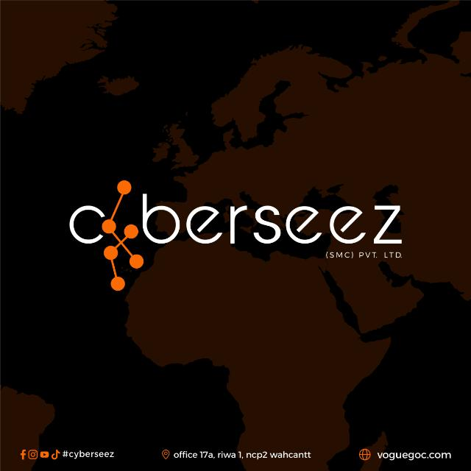

Subject: Enhance Team Productivity by 30%—Discover How!

Dear Umer,

Are you looking to increase your team's productivity and streamline your workflow? Consider achieving more in less time with a solution that adjusts to your specific company requirements.

Introducing **Cyberseez**, the ultimate productivity tool that will help you work smarter, not harder. With **Cyberseez**, you will encounter:

* **Seamless Collaboration**: Enjoy seamless collaboration with your team, whether in-office or remotely.
* **Automated Workflows**: Let **Cyberseez** handle repetitive processes, freeing up your team to focus on more important responsibilities.
* **Real-Time Analytics**: Access insights instantly for faster decision-making.

We recognize that every minute matters and **Cyberseez** will help you increase productivity, save a ton of hours, and improve your bottom line.

Test it out instead of simply believing what we say!

Get a **free trial now** and experience how **Cyberseez** can change the way you operate. In addition, you will receive a **special 20% discount** on your first year of membership if you sign up within the next **7 days**.

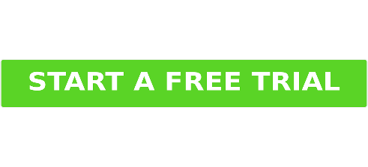

Thank you for considering **Cyberseez** as your go-to productivity solution. We’re confident you’ll see the difference from day one.

Best regards,

Sibgha Bint-e-Bashir

HR

Cyberseez Academy

03150891947